FACSIMILE/EMAIL TRANSMISSION

TO: James Waters
Chicago Area Undergraduate Research Symposium

FROM: Danielle Marziani

FAX/EMAIL: jswaters@uchicago.edu

PAGES (WITH COVER): 9

RE: Initial Proposal

James Waters
Chicago Area Undergraduate Research Symposium
1400 S. Lakeshore Drive
Chicago, IL 60605

Dear James:

Thank you for thinking of Blue Plate when planning your event at the Chicago Cultural Center. Please find an initial proposal for a seated dinner on April 1, 2006 from 5-6:30pm for 150 guests. Remember that this is merely a starting point. Revisions can be made based on your menu preferences and/or budget parameters.

We are excited to have the opportunity to submit this proposal and are confident Blue Plate will exceed your expectations. For over 20 years Blue Plate has been planning, staging and executing the finest events in Chicago. We work with our customers on every aspect of event planning, from venue choice, to design and theme development. Blue Plate takes pride in delivering exceptional results for our clients.

If I can answer any questions or be of assistance, feel free to contact me.

We look forward to creating a memorable evening for you and your guests!

Sincerely,
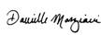
Danielle Marziani Kristy Pozulp
Sales Consultant Event Specialist

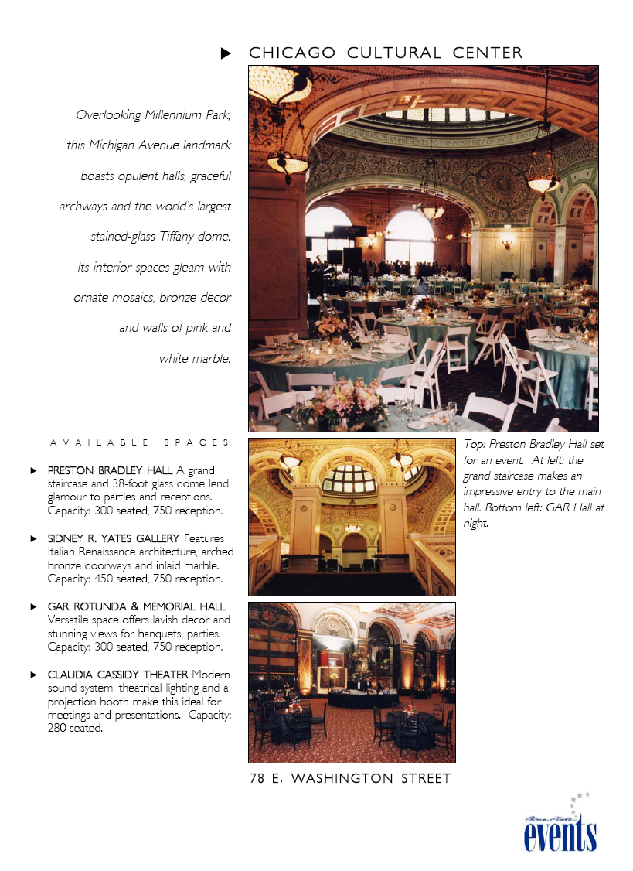
Prepared for Chicago Area Undergraduate Research Symposium
Dinner Reception
Chicago Cultural Center - Preston Bradley Hall
April 1, 2006

Menu A

First Course…

Baby Greens with Papaya Slices and Dried Apricot Slivers
Garnished with Roasted Pistachios and Feta Cheese
Tossed in an Apricot Vinaigrette

Waiters to pass baskets of
Seasonal Breads and Rolls

Butter Rosettes to the Bread Plate

Entrée…

Carved New York Strip Steak
With Pink Peppercorn Sauce
and
Grilled Filet of Salmon
With a Mango Raspberry Glaze

Au Gratin Potato Triangles

Mélange of Asparagus
With Pearl Onions, Shiitake Mushrooms
And Red Pepper Diamonds

Dessert…

Chocolate Molten Cake
Served Warm with a Dark Chocolate Filling
Garnished with Fresh Berries and Raspberry Coulis

IntelligentsiA Regular and Decaffeinated Coffees
Served with Cream, Sugar and Sweetener

$31.00 per person

Prepared for Chicago Area Undergraduate Research Symposium
Dinner Reception
Chicago Cultural Center - Preston Bradley Hall
April 1, 2006

Menu B

First Course…

Fresh Baby Greens Mixed Greens with Mandarin Oranges,
Walnuts, Crumbled Blue Cheese
Tossed with a Balsamic Vinaigrette

Waiters to pass baskets of
Seasonal Breads and Rolls

Butter Rosettes to the Bread Plate

Entrée…

Herb Crusted Beef Tenderloin
with Pinot Noir Jus
and
Artichoke stuffed Chicken Breast
with Provençal Tomato Relish

Roasted Garlic Mashed Potatoes
Sugar Snap Peas tossed with Red Peppers

Fresh Chervil Potato Crisp to Garnish

Dessert…

Three Apple and Walnut Bread Pudding
With French Vanilla Ice Cream and Warm Caramel Sauce

IntelligentsiA Regular and Decaffeinated Coffees
Served with Cream, Sugar and Sweetener

$33.00 per person

BAR / BEVERAGE OPTIONS:

All Beverages provided by Blue Plate. Blue Plate can provide:

Standard Dinner Wine:
- Morro Bay Chardonnay and/or Camelot Cabernet Sauvignon or comparable items to be served with dinner.
- $6.50 per person

Or

Premium Dinner Wine:
- DeLoach Chardonnay and/or Turner Road Cabernet Sauvignon or comparable items to be served with dinner.
- $ 8.50 per person

SERVICE PERSONNEL RECOMMENDATIONS

- Total service hours are based on a 4-hour minimum, load-in & travel time for Head Butler and Porters, set-up, party, and breakdown requirements

1 Head Butler @ $32.00 an hour
2 Service Captains @ $27.00 an hour
13 Waitpersons @ $24.00 an hour
1 Head Chef @ $29.00 an hour
4 Assistant Chefs @ $23.00 an hour
1 Porter @ $19.00 an hour

Please note: - Any changes in projected service hours will result in an additional labor charge.
- Gratuities are not included and are left to the client’s discretion.

LINEN
Solid: Color to be determined
Linen Napkins
120" rounds

EQUIPMENT

Tables and chairs

*All tables and chairs provided by Venue

60-inch round tables for seating
Versailles Chairs

White Bavarian China:
Oversize Dinner Plates
Dinner Plates
Dessert Plates
Bread and Butter Plates
Salad Plates
Cups & Saucers

Monaco Flatware:
Knives
Forks
Salad Forks
Teaspoons
Butter Knives
Dessert Forks

Excalibur Glassware:
Water Goblets
Wine Glasses

Table Appointments:
Creamer & Sugar Sets
Bread Baskets
Salt and Pepper Shakers
Table Numbers and Stands

Miscellaneous Equipment:
Serving Tongs
Glass Pitchers
Ten-Gallon Igloos
Lexons
Garbage Cans
Tray Stands
Waiter Trays
Portable Oven “Cave”

Coffee Service Equipment Including:
Cream Pitchers and Sugar Bowls
Coffee Makers
Coffee Pourers
Glass Mugs

Disposables:
White Cocktail Napkins

FLOWERS/DECORATIONS:
We would be happy to assist you with floral decorations. Prices vary based on selection.

Contract
Page 1

Client Name: Chicago Area Undergraduate Research Symposium | Today’s Date: November 8, 2026
Contact Name: James Waters | Salesperson: Danielle Marziani
Address: 1400 S. Lakeshore Drive | Date of Event: April 1, 2006
Chicago, IL 60605 | Time of Event: 5:00pm-6:30pm
Phone: 312.665.7759 | Guest Count: 150
Email: jswaters@uchicago.edu | Location: Chicago Cultural Center - Preston Bradley Hall
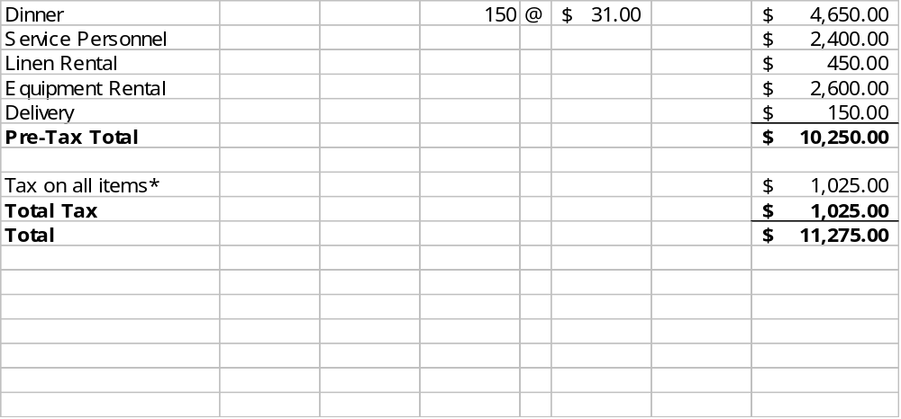

All items are subject to sales tax of 10%. **Gratuities are optional and left to your discretion.
In acceptance of the terms set forth on pages one and two of this contract:

For Client Date | For Blue Plate Catering Date
Client: Chicago Area Undergraduate Research Symposium, James Waters
Event Date: April 1, 2006
In consideration of the menu, equipment and other services outlined above, Blue Plate Catering, Ltd. (Blue Plate) and the client, as named above, agree as follows:
Blue Plate, may, at its sole discretion, make reasonable substitutions. Pricing may be adjusted for market price variations that are beyond the reasonable control of Blue Plate.
Guest Count: The final guest count must be received by Blue Plate, in writing, at least seven (7) business days prior to the event date. Any increase or decrease in the guest count must be approved by Blue Plate, and any count increases that occur within a 48 hour period may result in an increased price per person or product substitution, based on supplier pricing and availability. The above price estimates are based upon 150 Guests. In the event that the final guest count is less than eighty (80) percent of the original count; Blue Plate may increase the above menu pricing. The client shall pay for no less than the final guest count regardless of the actual number of persons at the event.
Payment Terms: A deposit equal to fifty (50) percent of the total amount due is required upon acceptance of this contact. The remaining balance due, based on the final guest count, shall be paid to Blue Plate prior to the commencement of the event. Payments made within five business days of the event shall be by certified or cashiers check only.
Any final changes in quantities, equipment, service, etc. or other additional changes will be billed to the client on a final invoice. Any amounts not paid within ten (10) days of the invoice date shall bear interest at a rate of 1.5% a month. The client shall pay any and all costs incurred in the collection of the amount due including, without limitation, reasonable attorney's fees.
Default: Failure of the client to timely pay Blue Plate the foregoing amounts due shall constitute a default by the client. Upon a default by the client, Blue Plate, at its sole discretion, may (I) terminate this contract and retain all amount paid to Blue Plate as liquidated damages, or (II) enforce the terms of this contract through any and all remedies that it has in law or in equity. In no event of default shall Blue Plate be liable to client for any amount in excess of amounts paid to Blue Plate plus $250.00. Said payment constitutes the client's sole and exclusive remedy and the client hereby relinquishes any and all causes of action, which the client might otherwise have in law or in equity. Neither Blue Plate nor the client shall be in default if its failure to perform under this contract was attributable to scarcity of labor, materials or public utilities, strikes, lock-outs, inclement weather, wars, riots, civil disobedience or national emergency, acts of God, theft, vandalism, fire or other interruption or delay beyond such party's reasonable control.
Cancellations: Fifty (50) percent of the required deposit shall be refunded if written cancellation is received by Blue Plate not less than one month prior to the event date. The full deposit shall be retained by Blue Plate, in addition to any and all remedies in law or in equity, where the event is canceled less than one month prior to the event date.
Client's Possessions: In the event that the client requests that Blue Plate utilizes any dishes, glassware, serving pieces, appliances or other personal possessions (collectively "Articles") of the client, whether in the client's home or in a public forum, the client shall be solely responsible for the care and return of the Articles and the client hereby waives, releases, indemnifies and holds harmless Blue Plate and its agents and employees from and against any and all liabilities to the client for loss or damage while using said Articles.
Initialed:
For Client Date For Blue Plate Catering Date

Please return all pages of the contract, either by fax or mail.

